**Tutorial: Using Processing to Generate an Android App**

To build an Android app with Processing is simpler than it seems when you have the proper tools and approaches. To get started with the project, I use the same code as the one I used to show Michael the various controllers we can use for a control panel for the Android app. To get access to the code, locate it in the same file as this tutorial. (Please email Hieu or me (Jonathan) if you have any questions: [hieutn3@uci.edu](mailto:hieutn3@uci.edu), [cylim1@uci.edu](mailto:cylim1@uci.edu))

**Below are the steps needed to successfully create an Android app:**

1. Open the program needed to build the app with.
2. After opening the program, locate the scroll list labeled as “Java” on the top right of the program.
3. Click into the scroll list, find the option “Add Mode….”, and select it.
4. As soon as you select “Add Mode…”, a screen named “Mode Manager” will pop up, and so you can install the mode called “Android Mode” located in the Mode Manager.
5. 5. Now, go ahead and download the Android SDK from this link:
6. [http://developer.android.com/sdk/index.html](http://developer.android.com/sdk/index.html )
7. After downloading and installing Android SDK, run the Processing program, and either locate or download the downloaded Android SDK file if Programming asks you where the Android SDK is.
8. If you are running the program on the tablet from CalPLUG, please continue with the procedures from Step 10. If not, please refer to the next step.

**Picture of the Tablet from CalPLUG**

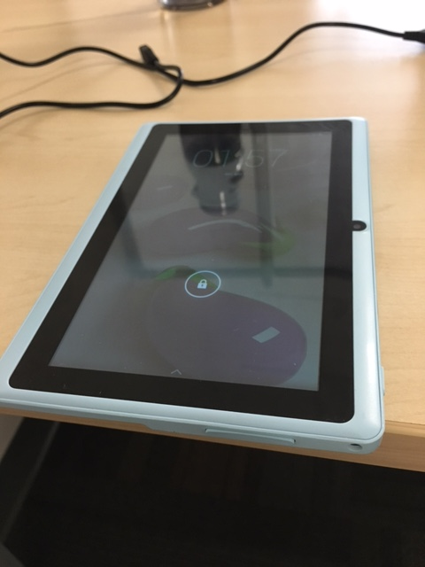

1. Last but not least, connect your Android device to the computer (Make sure that you’ve already enabled USB Debugging on your Android device prior to connecting it to your computer), and run the program.
2. There you go, you have created an app on your Android device.
3. Please download the program called MobileGo from the following link: <http://www.wondershare.net/mobilego/?icn=nav>

(**Note:** MobileGo works only on Windows 8/7/Vista/XP and any IOS devices)

1. Now, open your Processing program.
2. Search for Device Manager on your computer, and try to locate the tablet you are using to run the program on in the Device Manager.
3. After locating the device, right click, and click into Properties.
4. In Properties, find the tab called “Driver” and click into it.
5. Uninstall the original driver on the tablet, and reinstall the driver from the MobileGo program.
6. Then, go back to the Processing program, run it as usual, and you should be able to turn your Processing program into an Android app.

**When Run with Java Mode**

Default Tab

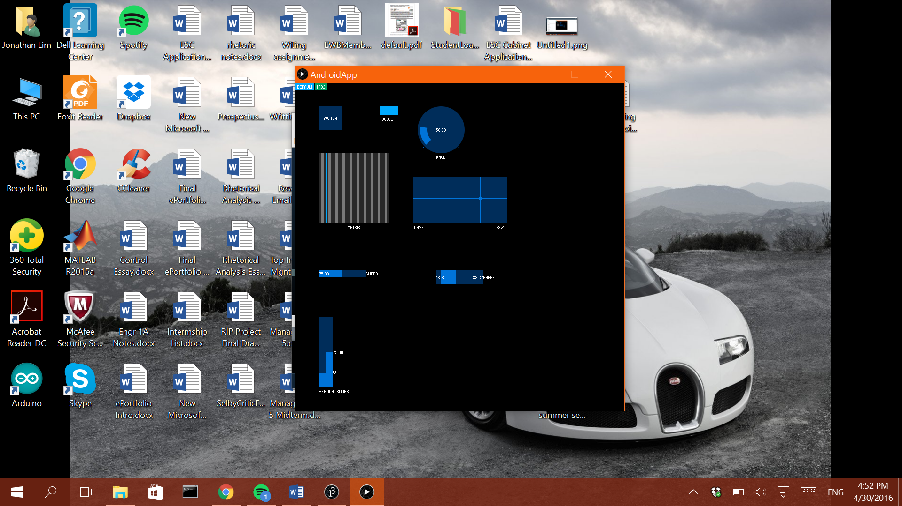

Second Tab

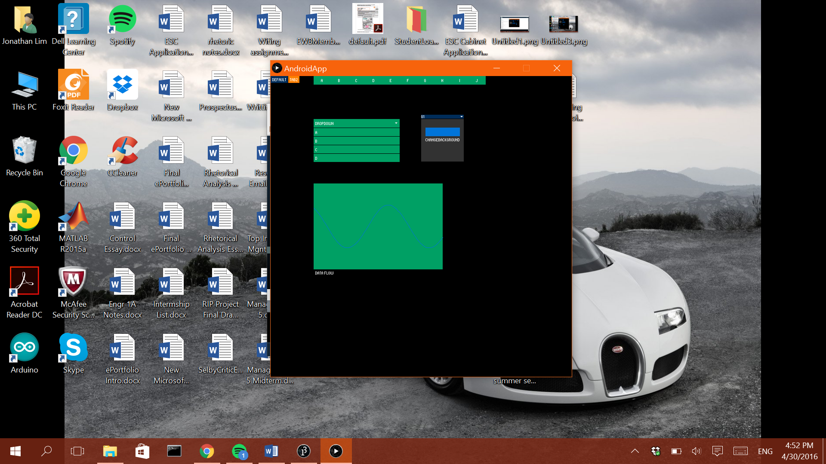

**When Run with Android Mode (On Android Device)**

Default Tab

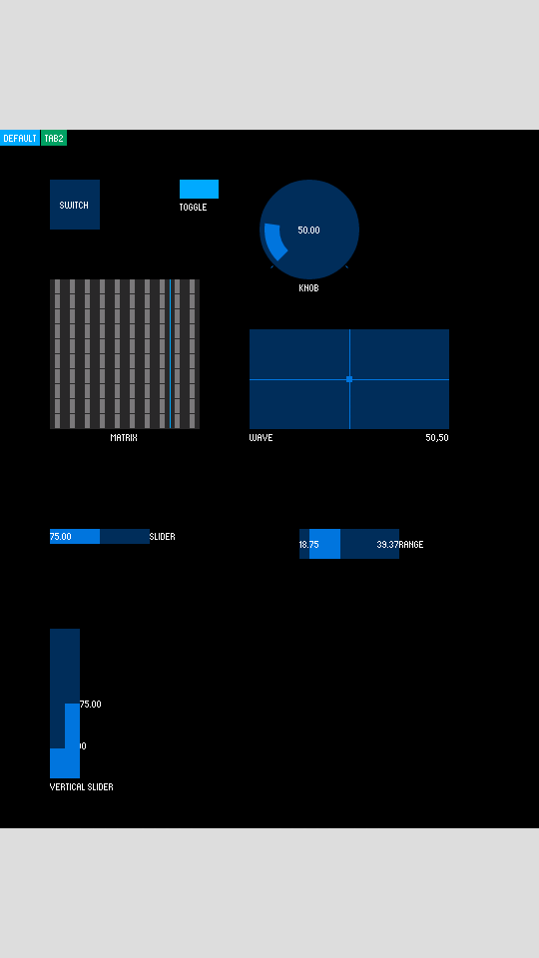

Second Tab

